FUNDAMENTAL OF COMPUTER PROGRAMMING

ASSIGNMENT 1

[Company name] | [Company address]

SUBMITTED BY:

Hanan Majeed

CMS ID: 519166

2024

TASK 1:

Write a program to get a natural number N from the user and generate N first Fibonacci series numbers.

INPUT:

#include <iostream>

using namespace std;

int main() {

int N;

cout << "Enter a value for N: ";

cin >> N;

long a = 1; // Initialize the first Fibonacci number (F(1))

long b = 1; // Initialize the second Fibonacci number (F(1))

//LONG IS USED TO INCREASE RANGE

// Print the Fibonacci series

cout << "Fibonacci series: ";

for (int i = 1; i <= N; i++) { // Loop from 1 to N to generate Fibonacci numbers

cout << a << " "; // Output the current Fibonacci number (F(i))

long next = a + b; // Calculate the next Fibonacci number (F(i+1) = F(i) + F(i-1))

a = b; // Update a to the previous b (move to the next number in the series)

b = next; // Update b to the newly calculated Fibonacci number

}

cout << endl;

return 0;}

OUTPUT:

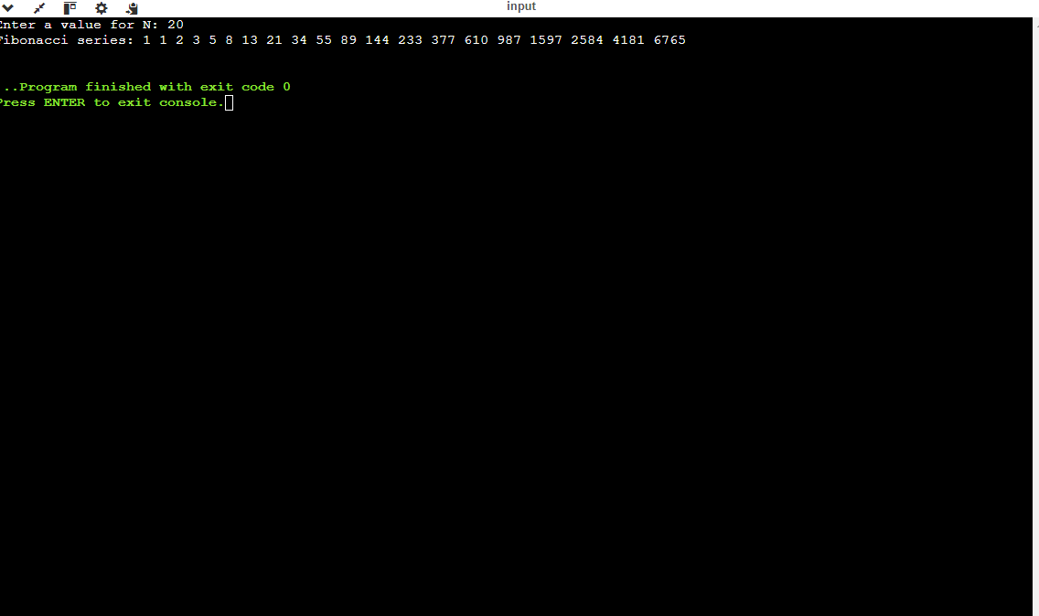

TASK 2:

Write a program that gets two natural numbers from the user and calculates the Least Common Multiple (LCM) of those two numbers.

INPUT:

#include <iostream>

using namespace std;

int main() {

int num1, num2; // Declare variables to store the two numbers

cout << "Enter the first number: ";

cin >> num1;

cout << "Enter the second number: ";

cin >> num2;

int a = num1, b = num2; // Initialize variables for the GCD calculation

// Calculate GREATEST COMMON DIVISOR(GCD) using the Euclidean algorithm

while (b != 0) {

int temp = b; // Store the value of b in a temporary variable

b = a % b; // Update b to be the remainder of a divided by b

a = temp; // Update a to the previous value of b

}

int c = a; // c now holds the greatest common divisor (GCD)

// Calculate LCM using the relationship between LCM and GCD

int lcm = (num1 \* num2) / c; // LCM = (num1 \* num2) / GCD

cout << "The LCM of " << num1 << " and " << num2 << " is: " << lcm << endl;

return 0;

}

OUTPUT:

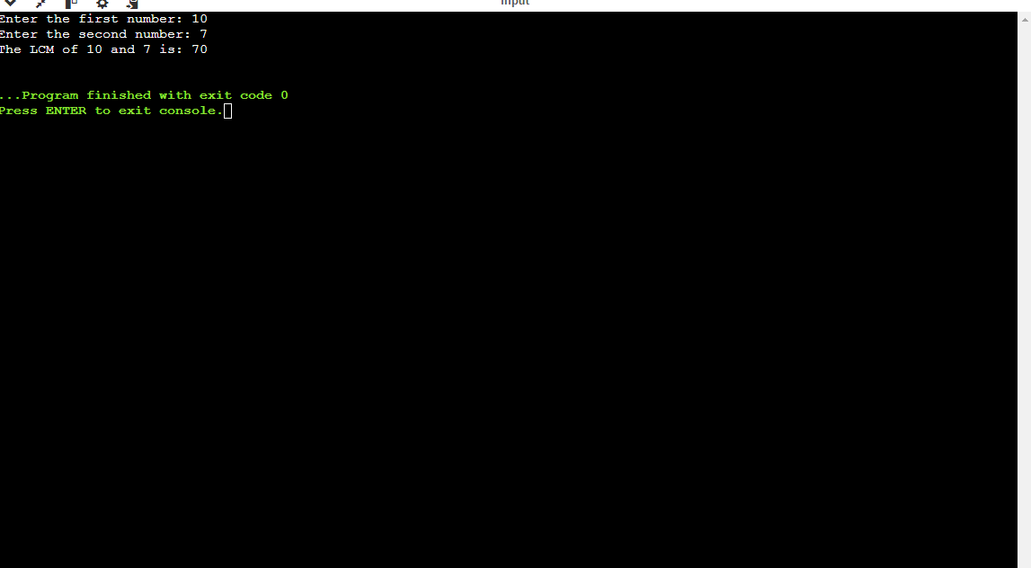

TASK 3:

INPUT:

#include <iostream>

using namespace std;

int main() {

int rows; // Variable to store the number of rows for the STAR PYRAMID

cout << "Number of rows = ";

cin >> rows;

// 1st for loop: Iterate from the specified number of rows down to 1(FOR PRINTING ROWS)

for (int i = rows; i >= 1; i--) {

// 2nd for loop: Print spaces before the stars to center them

for (int j = 0; j < rows - i; j++) {

cout << " "; // Print two spaces for each space needed

}

// 3rd for loop: Print the stars for the current row

for (int k = 0; k < (i \* 2) - 1; k++) {

cout << "\* "; // Print stars, with a space after each star

}

cout << endl;}

return 0;}

OUTPUT:

NO OF ROWS=7

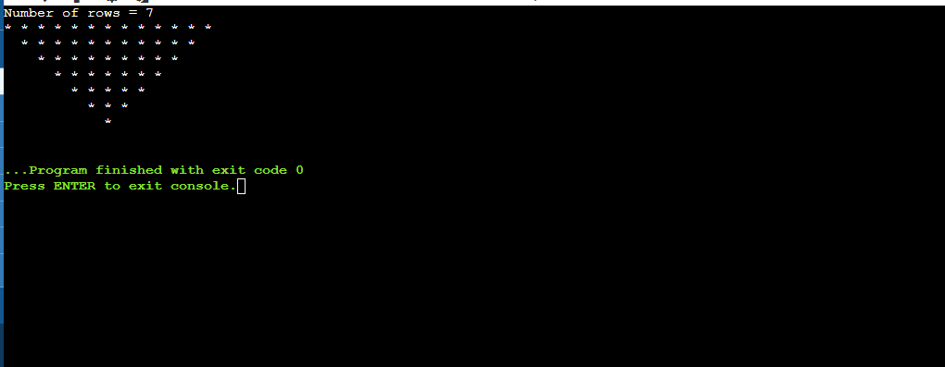

NO OF ROWS =5

